ANNUAL CLINTON HISTORICAL SOCIETY APPLEFEST

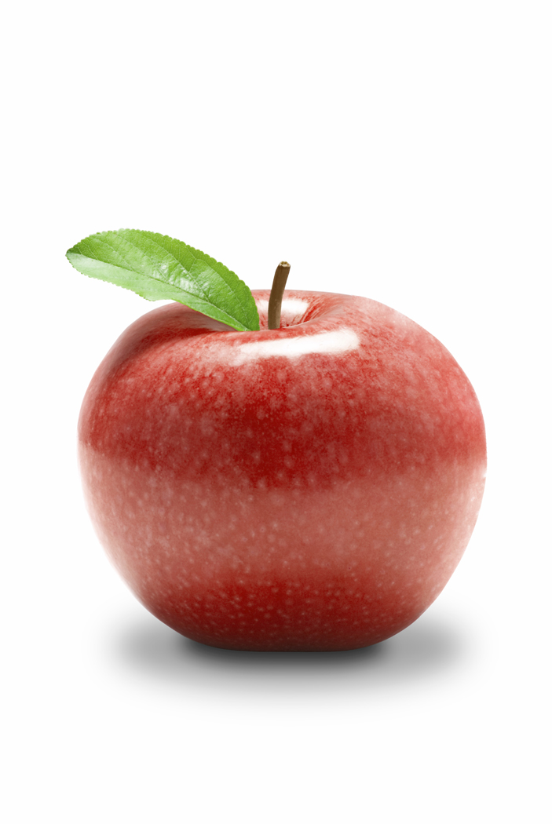
Sunday, September 19, 2021
12:00-4:00p.m.
10X10 space $15.00
Historic Downtown Clinton

Booth Registration:
Name: ________________________________________________
Address: ______________________________________________
_______________________________________________
Phone: ______________________________

Number of Spaces Requested_______ ($15.00 per 10X10 space)
Total Enclosed $________

Description of Items to be sold: ______________________________________________________________________
____________________________________________________________________________________________________________________________________________

Please provide your own tables/chairs.
No electricity is available.

Please make check payable to Clinton Historical Society. Booth requests should be returned ASAP.
Mail to: Clinton Historical Society
P.O. Box 1250
Clinton, OH 44216

Please be prepared to have your booth open for business at 12:00p.m. If you have any questions please call Lee Ann Dreurey 330-882-8137 or Beverly Waseman 330-608-3230.

We will be available on the festival grounds (near Village Hall) beginning at 9:30 a.m. September 19, 2021.

Thank you in advance for participating in the APPLEFEST.

